***PAAREES PERFUMES***

***VERSACE***

***FOR WOMEN***

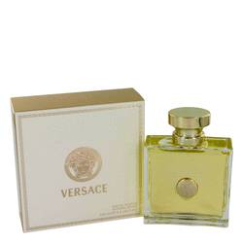

# 

# *Versace Signature*

# *Description:*

Versace Signature by Versace Perfume. If you are looking for a trendy, glamorous fragrance to add to your feminine collection of elixirs, try Versace Signature by Versace. Introduced in 2007 this alluring floral fragrance uses opening notes of guava, black currant, white lilacs and purple wisteria and sophisticated heart notes of orchid and lotus flowers. The sensual base notes combine musk and cedar wood. Wear this fabulous fragrance and feel like a star every time you walk into a room.